Test Case: tc005_SPX_Dev5_Crear_Requisicion_Spot_Con_FAD_Tipo_Cobro_Project
Step 1 - Enter username and password and click to button Enter: Credentials Entered
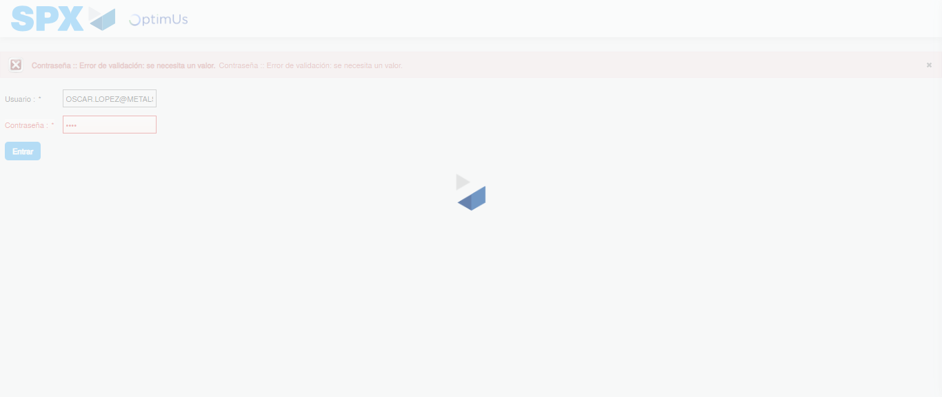Image file-name: QC_Testing-tc005_SPX_Dev5_Crear_Requisicion_Spot_Con_FAD_Tipo_Cobro_Project-1784570400147

Step 2 - Select to UEN and Access to Spot Buy Requisitions : UEN Correctly selected and Correct access
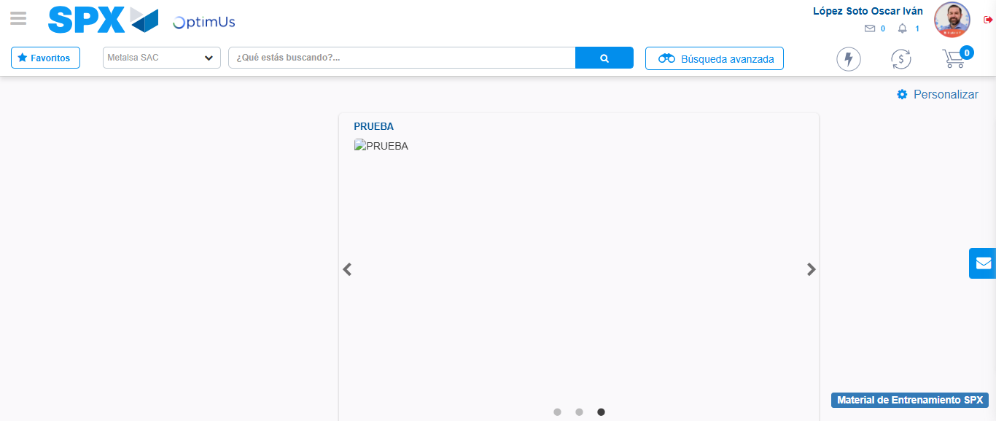Image file-name: QC_Testing-tc005_SPX_Dev5_Crear_Requisicion_Spot_Con_FAD_Tipo_Cobro_Project-1784570470301

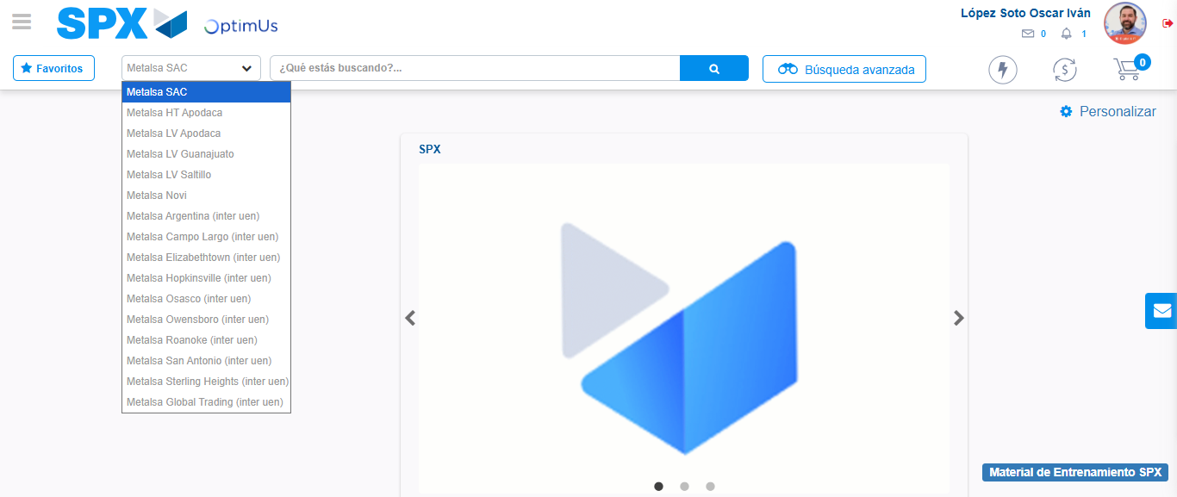Image file-name: QC_Testing-tc005_SPX_Dev5_Crear_Requisicion_Spot_Con_FAD_Tipo_Cobro_Project-1784570473208

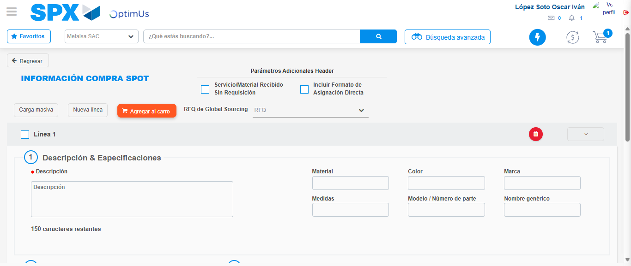Image file-name: QC_Testing-tc005_SPX_Dev5_Crear_Requisicion_Spot_Con_FAD_Tipo_Cobro_Project-1784570486226

Step 3 - Add FAD to Requisition: FAD Successfully Added
Image file-name: QC_Testing-tc005_SPX_Dev5_Crear_Requisicion_Spot_Con_FAD_Tipo_Cobro_Project-1784570486598

Image file-name: QC_Testing-tc005_SPX_Dev5_Crear_Requisicion_Spot_Con_FAD_Tipo_Cobro_Project-1784570486838

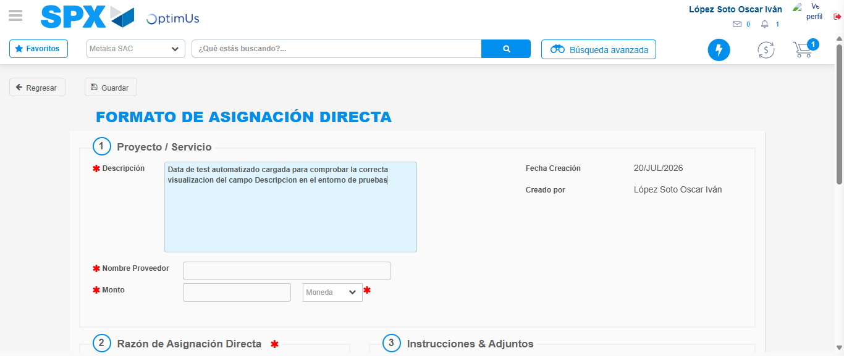Image file-name: QC_Testing-tc005_SPX_Dev5_Crear_Requisicion_Spot_Con_FAD_Tipo_Cobro_Project-1784570489893

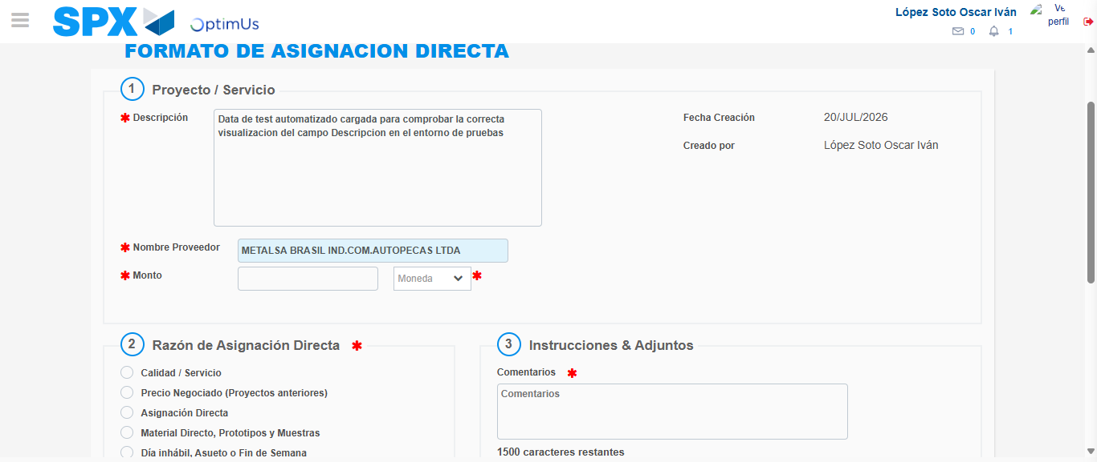Image file-name: QC_Testing-tc005_SPX_Dev5_Crear_Requisicion_Spot_Con_FAD_Tipo_Cobro_Project-1784570496627

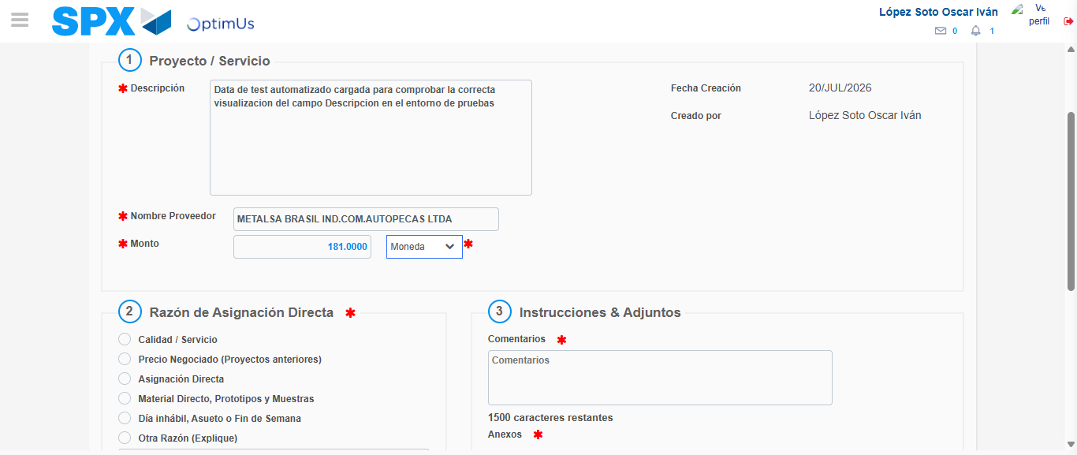Image file-name: QC_Testing-tc005_SPX_Dev5_Crear_Requisicion_Spot_Con_FAD_Tipo_Cobro_Project-1784570497166

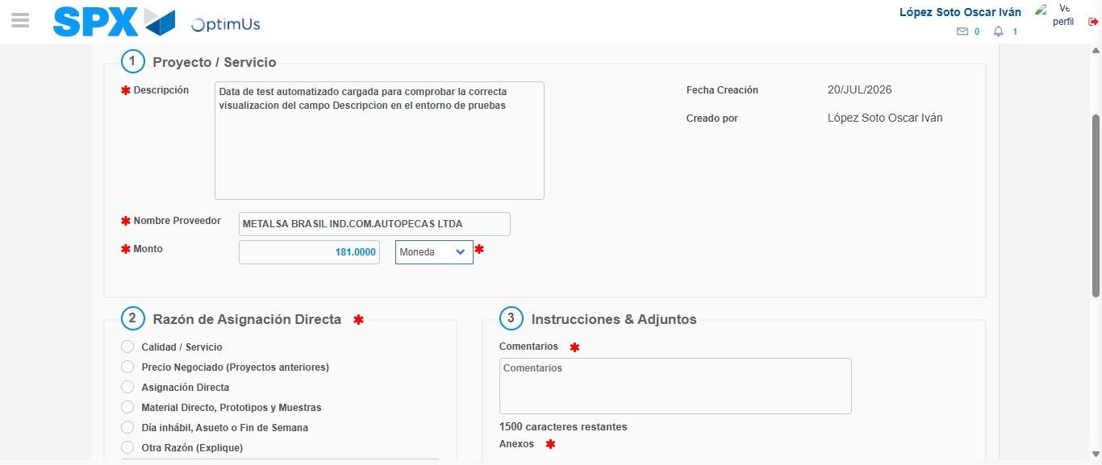Image file-name: QC_Testing-tc005_SPX_Dev5_Crear_Requisicion_Spot_Con_FAD_Tipo_Cobro_Project-1784570497443

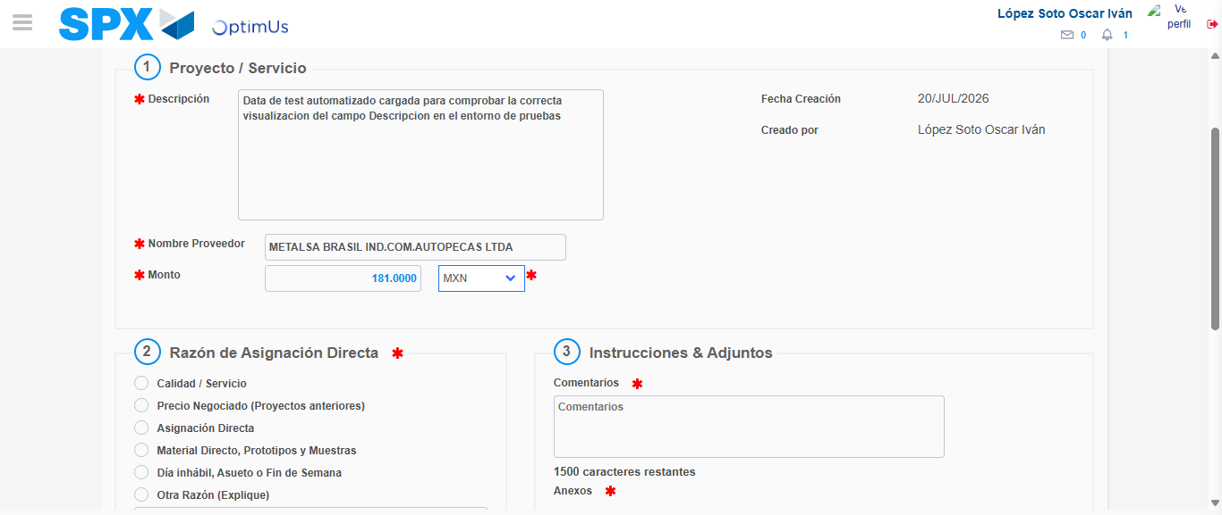Image file-name: QC_Testing-tc005_SPX_Dev5_Crear_Requisicion_Spot_Con_FAD_Tipo_Cobro_Project-1784570497908

Image file-name: QC_Testing-tc005_SPX_Dev5_Crear_Requisicion_Spot_Con_FAD_Tipo_Cobro_Project-1784570498159

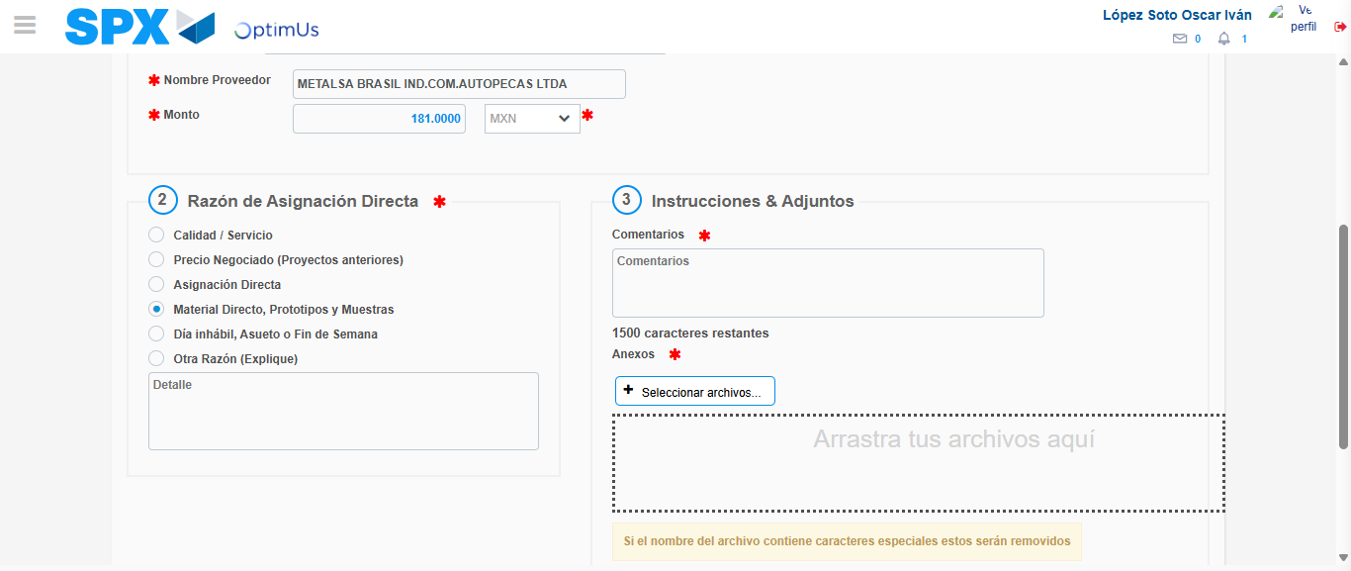Image file-name: QC_Testing-tc005_SPX_Dev5_Crear_Requisicion_Spot_Con_FAD_Tipo_Cobro_Project-1784570499131

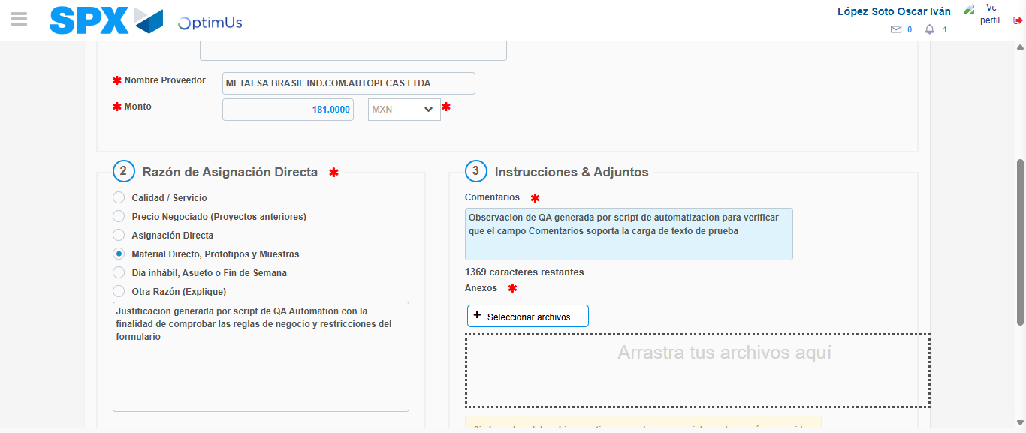Image file-name: QC_Testing-tc005_SPX_Dev5_Crear_Requisicion_Spot_Con_FAD_Tipo_Cobro_Project-1784570510554

Image file-name: QC_Testing-tc005_SPX_Dev5_Crear_Requisicion_Spot_Con_FAD_Tipo_Cobro_Project-1784570511572

Step 4 - Data Capture Spot Buy Requisition: Data captured correctly
Image file-name: QC_Testing-tc005_SPX_Dev5_Crear_Requisicion_Spot_Con_FAD_Tipo_Cobro_Project-1784570486598

Image file-name: QC_Testing-tc005_SPX_Dev5_Crear_Requisicion_Spot_Con_FAD_Tipo_Cobro_Project-1784570486838

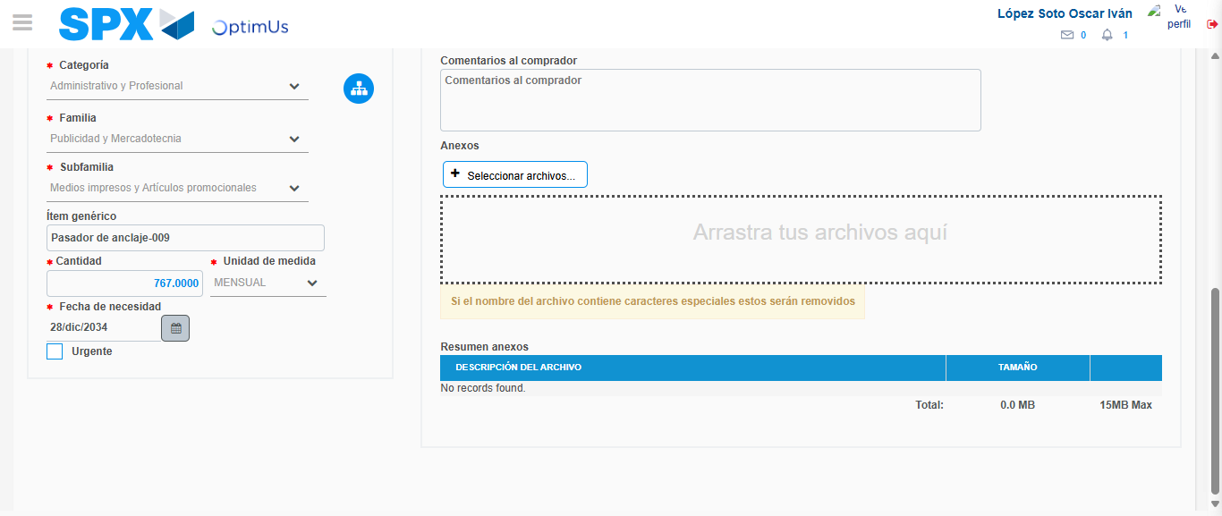Image file-name: QC_Testing-tc005_SPX_Dev5_Crear_Requisicion_Spot_Con_FAD_Tipo_Cobro_Project-1784570527130

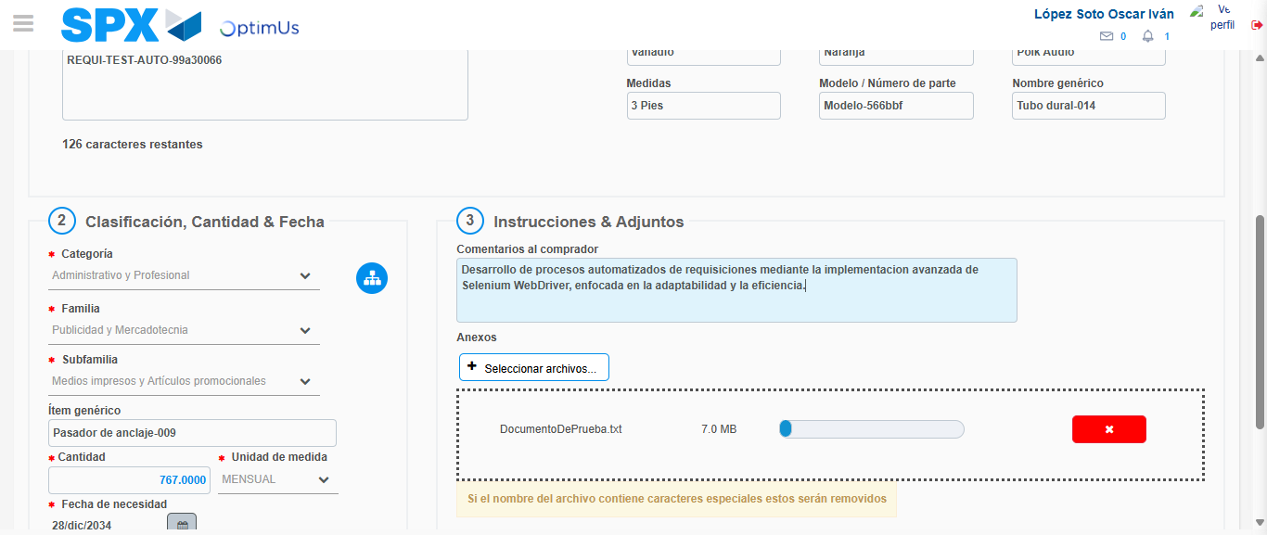Image file-name: QC_Testing-tc005_SPX_Dev5_Crear_Requisicion_Spot_Con_FAD_Tipo_Cobro_Project-1784570528179

Step 8 - Return to Main Page SPX : Return to Main Page SPX
Image file-name: QC_Testing-tc005_SPX_Dev5_Crear_Requisicion_Spot_Con_FAD_Tipo_Cobro_Project-1784570470301

Image file-name: QC_Testing-tc005_SPX_Dev5_Crear_Requisicion_Spot_Con_FAD_Tipo_Cobro_Project-1784570473208

Image file-name: QC_Testing-tc005_SPX_Dev5_Crear_Requisicion_Spot_Con_FAD_Tipo_Cobro_Project-1784570486226

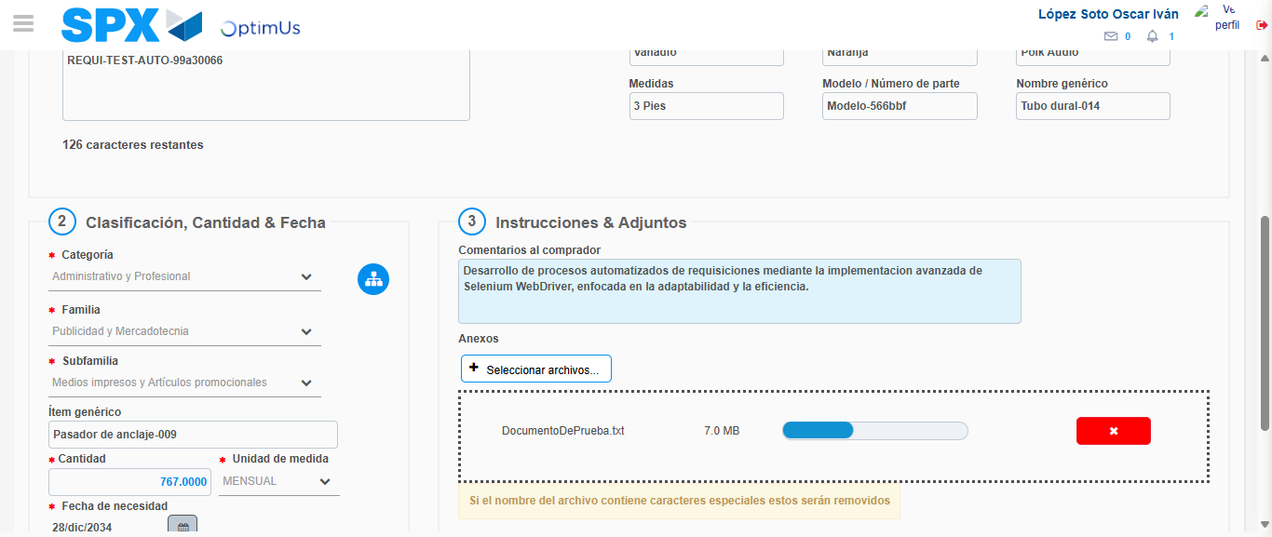Image file-name: QC_Testing-tc005_SPX_Dev5_Crear_Requisicion_Spot_Con_FAD_Tipo_Cobro_Project-1784570530427

Image file-name: QC_Testing-tc005_SPX_Dev5_Crear_Requisicion_Spot_Con_FAD_Tipo_Cobro_Project-1784570530618

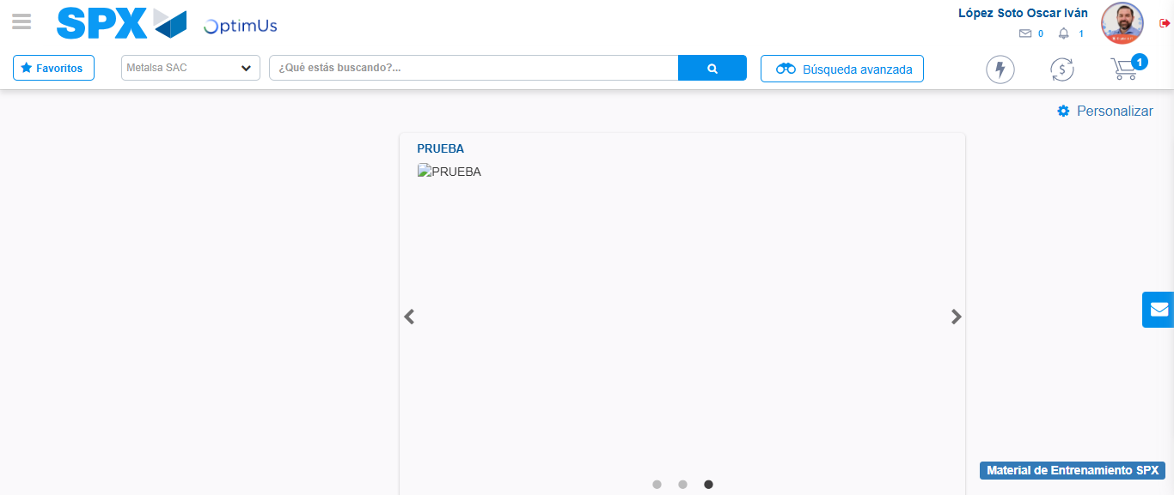Image file-name: QC_Testing-tc005_SPX_Dev5_Crear_Requisicion_Spot_Con_FAD_Tipo_Cobro_Project-1784570552026

Step 9 - Log Out : Log Out SPX
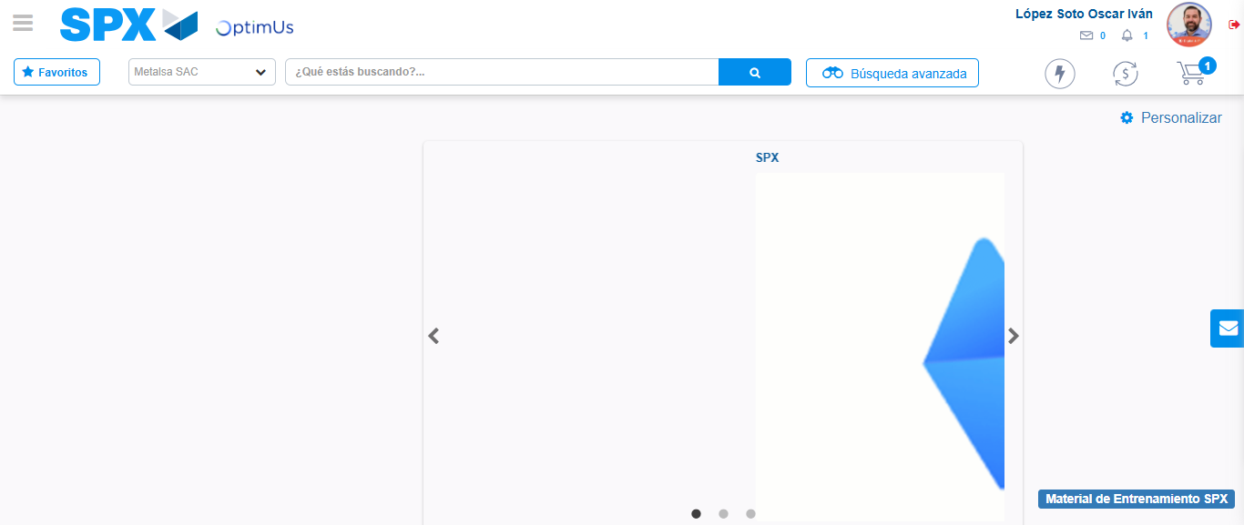Image file-name: QC_Testing-tc005_SPX_Dev5_Crear_Requisicion_Spot_Con_FAD_Tipo_Cobro_Project-1784570552334

